**

**JamesThewDOTcom**

**User Guide**

|  |  |  |
| --- | --- | --- |
| **Supervisor:** | *LE THANH NHAN* | |
| **Semester:** | *III* | |
| **Batch No:** | *T1.2208.M2* | |
| **Group No:** | *3* | |
| **Order:** | **Full name** | **Roll No.** |
| *1.* | *Bui Tran Anh Tri* | *Student1414230* |
| *2.* | *Pham Tien Duc* | *Student1414248* |
| *3.* | *Hoang Ngoc Phu* | *Student1396925* |
| *4.* | *Nguyen Hoang Trung* | *Student1414357* |

***December 2023***

# 

## Admin:

### Admin Login

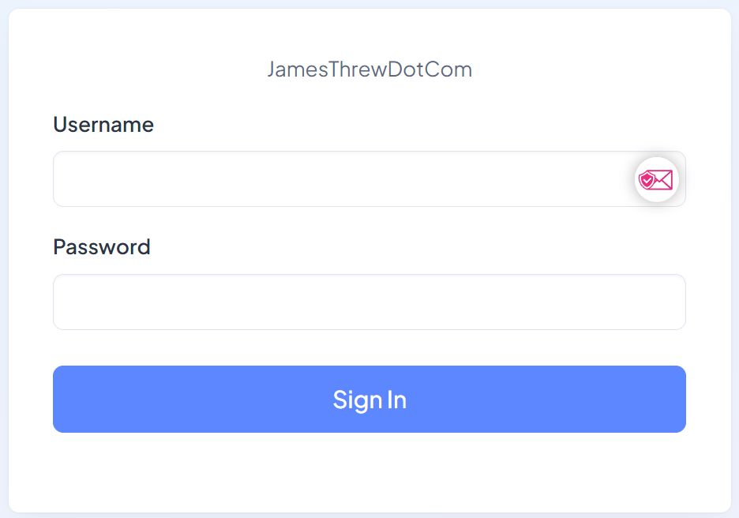

Description: Admin Dashboard Login

From: Dashboard/Login

To: Dashboard

### Admin Dashboard

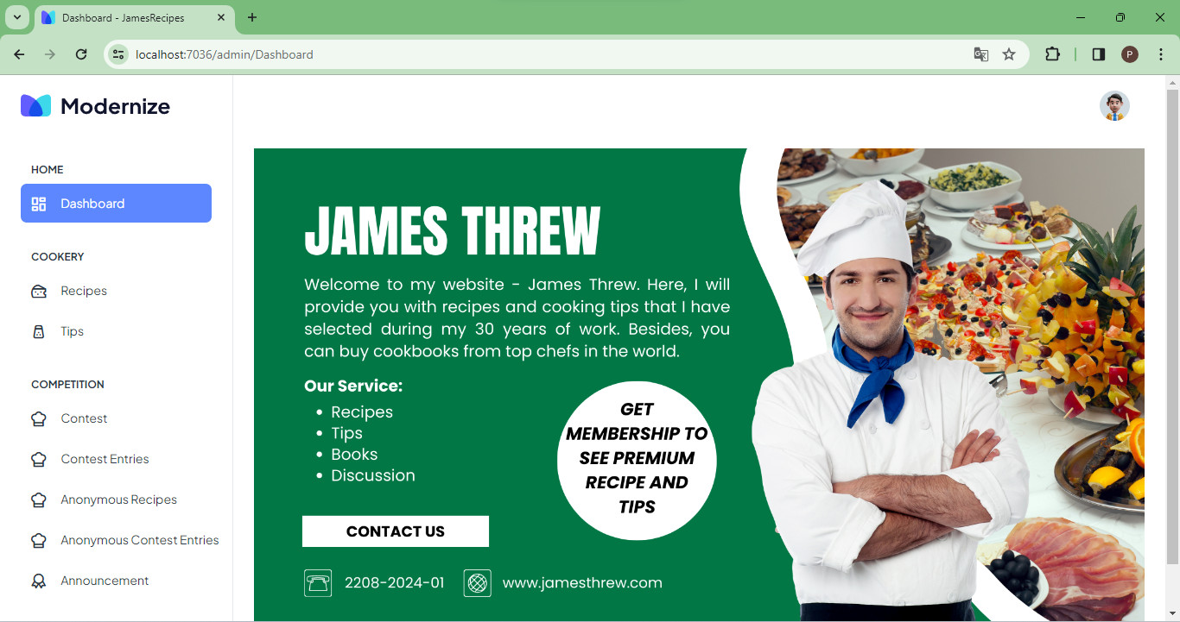

Description: Admin Dashboard

From: Login/Dashboard

To:

* Contests Management
* Recipes/Tips & Categories Management
* Books Management
* Accounts Management

### Contest Management

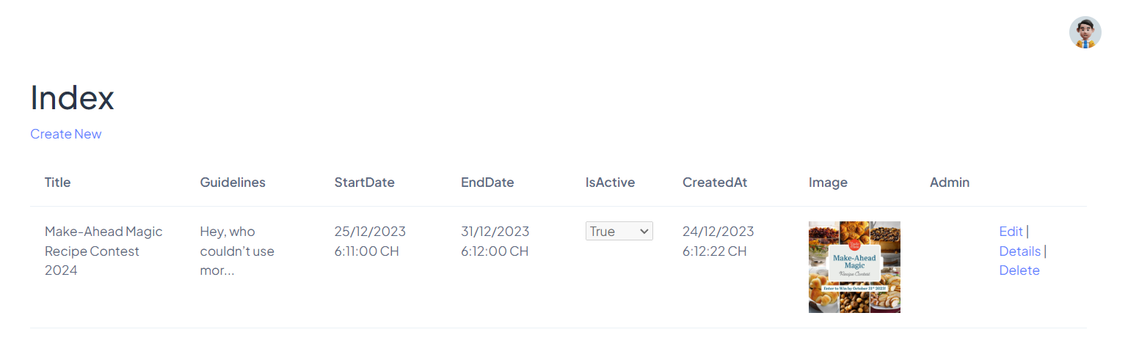

Description: Contest Management Page

From: Admin Dashboard

To:

* Create

* Edit

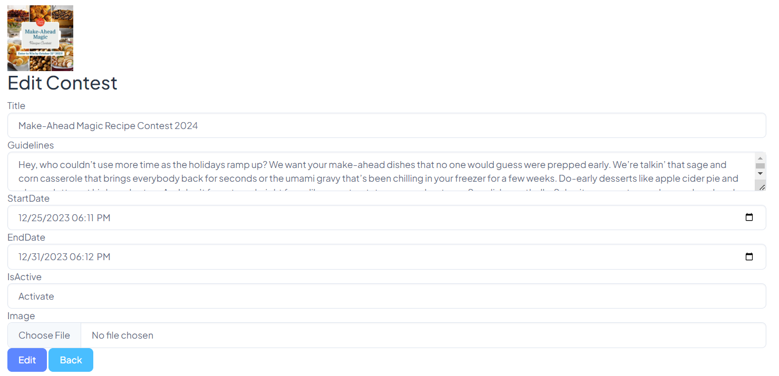

* Details

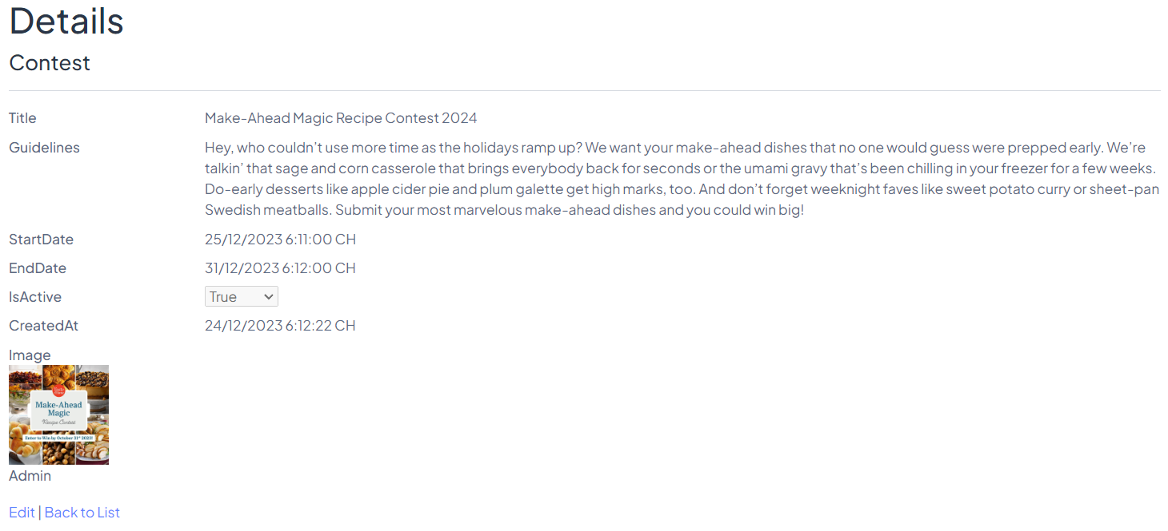

* Delete

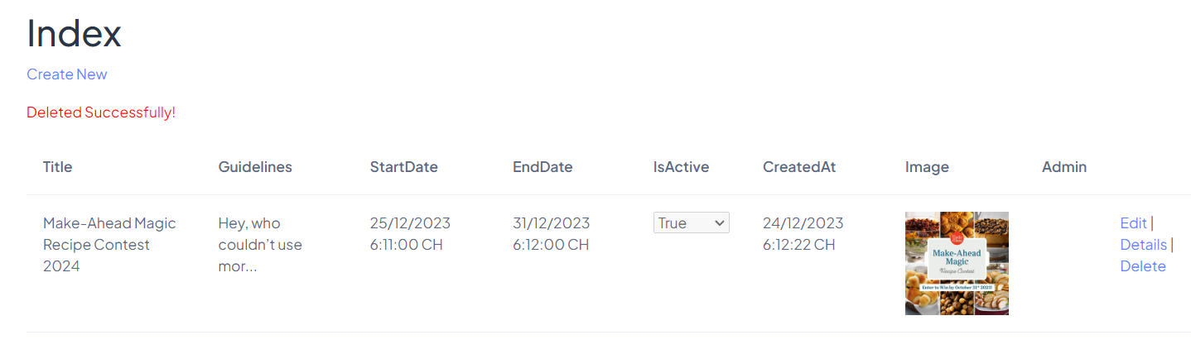

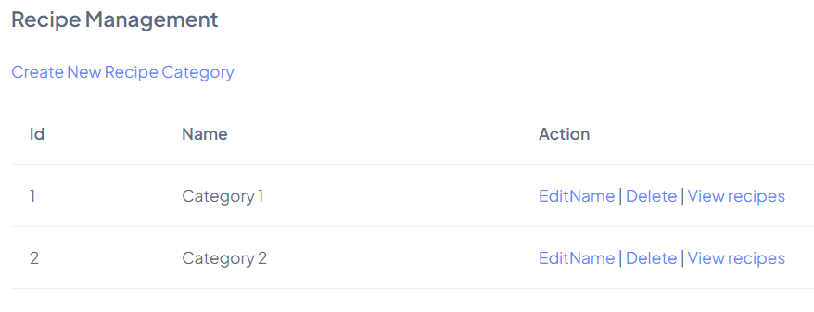

Description: Recipe Categories Management

From: Admin Dashboard

To:

* Create

* Edit

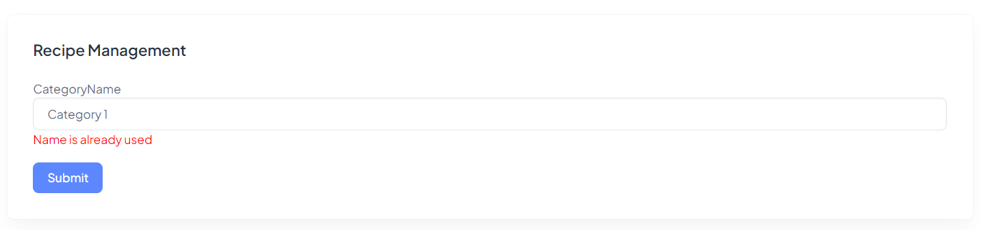

* Delete
* View Recipes

Description: Tips Categories Management

From: Admin Dashboard

To:

* Create

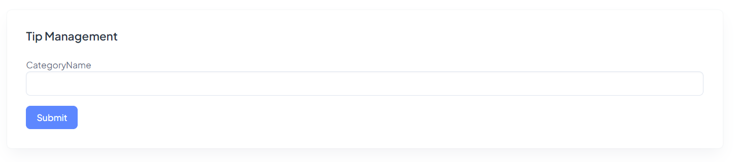

* Edit/Delete/View

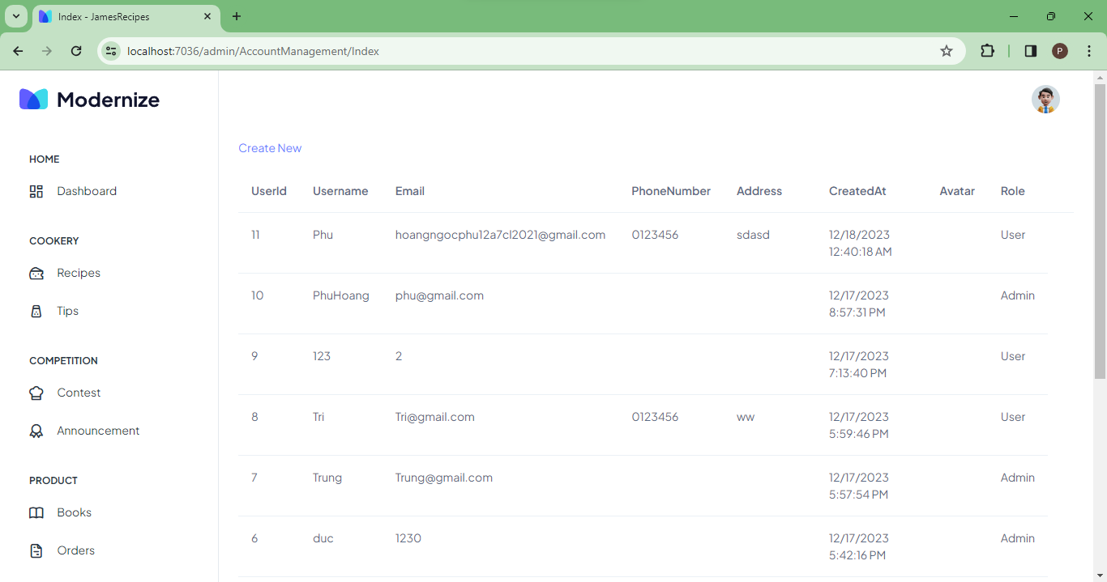

Description: Account Management

From: Admin Dashboard

To:

* Create
* Edit
* View

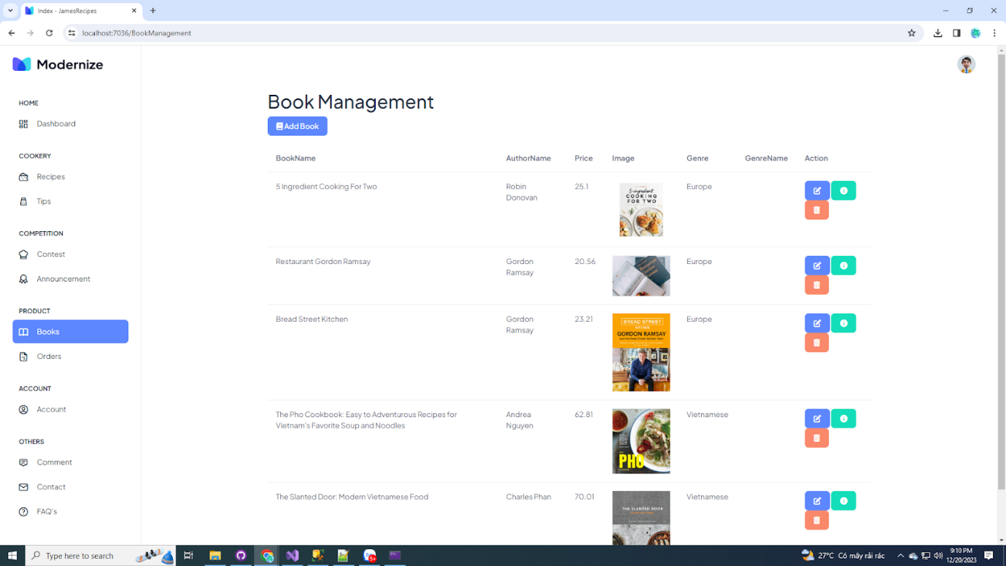

Description: Book Management

From: Admin Dashboard

To:

* Create
* Edit
* Delete
* View

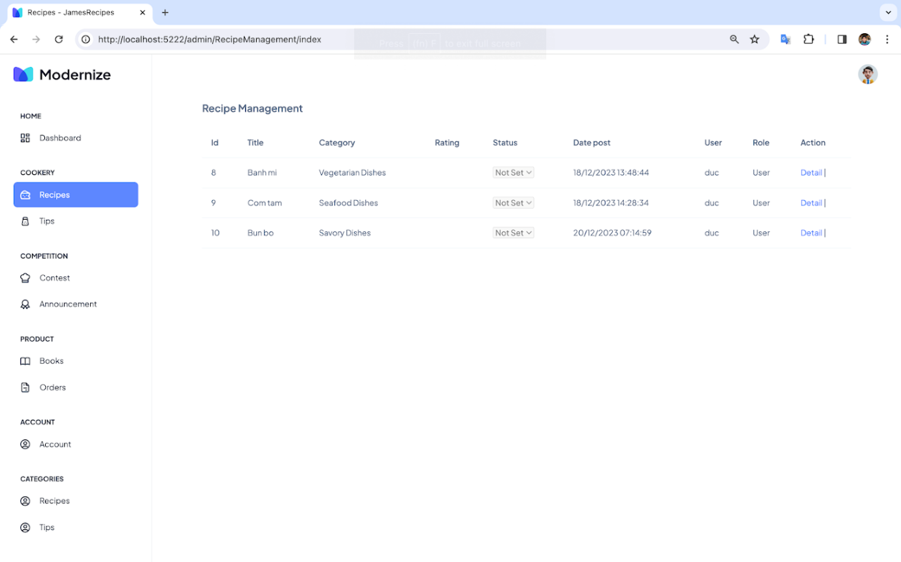

Description: Recipe Management

From: Admin Dashboard

To:

* Create
* Edit
* Delete
* View

Description: Tips Management

From: Admin Dashboard

To:

* Create
* Edit
* Delete
* View

## Frontend:

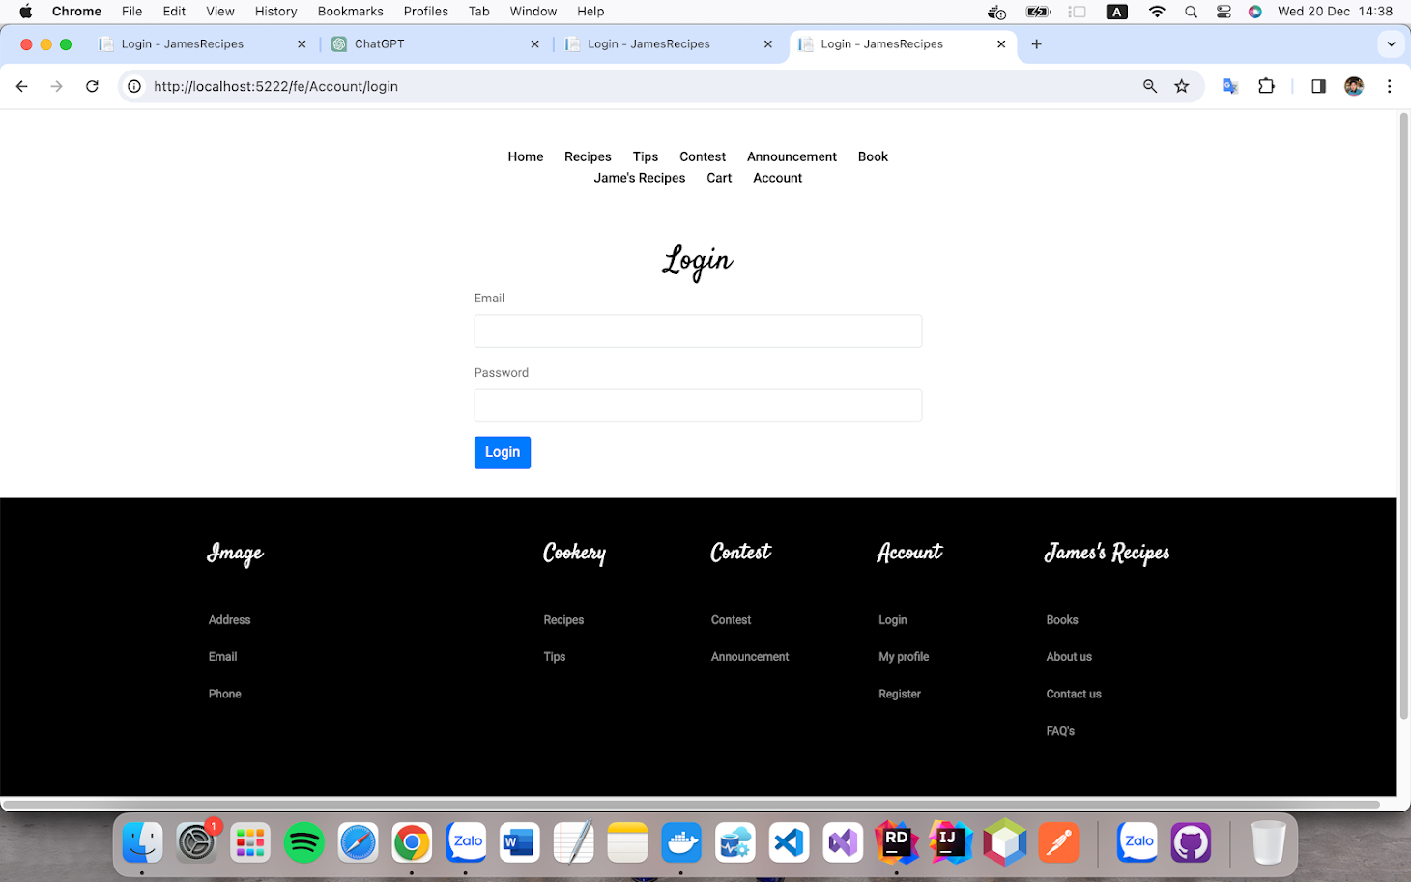

Description: User Login Page

From: fe/account

To: login

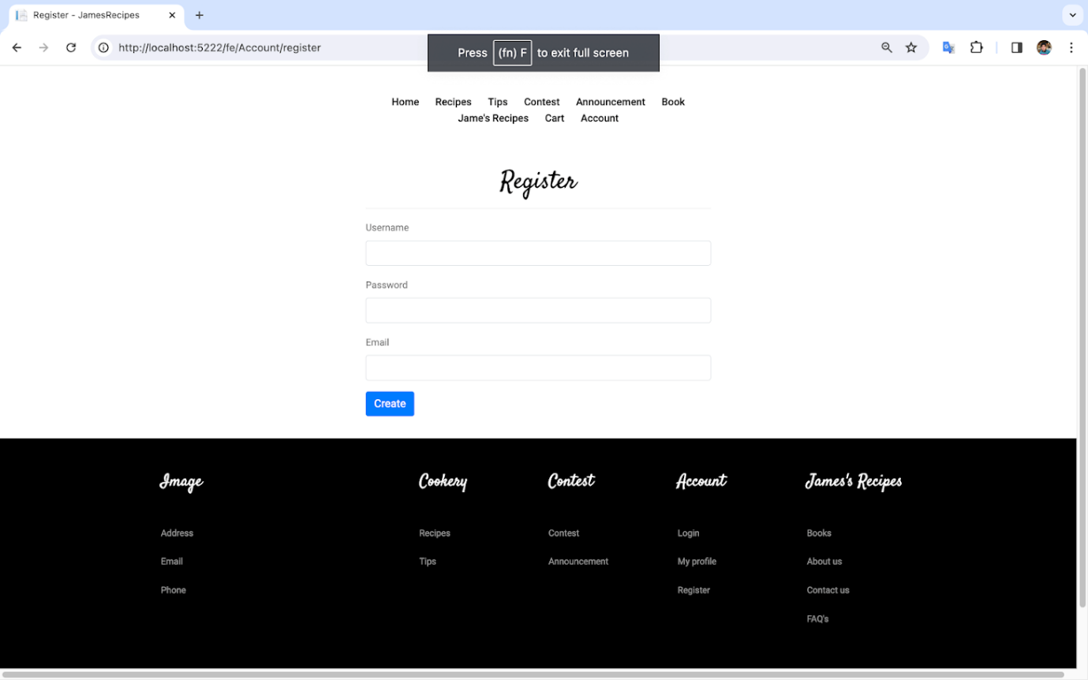

Description: User Register Page

From: fe/account

To: register

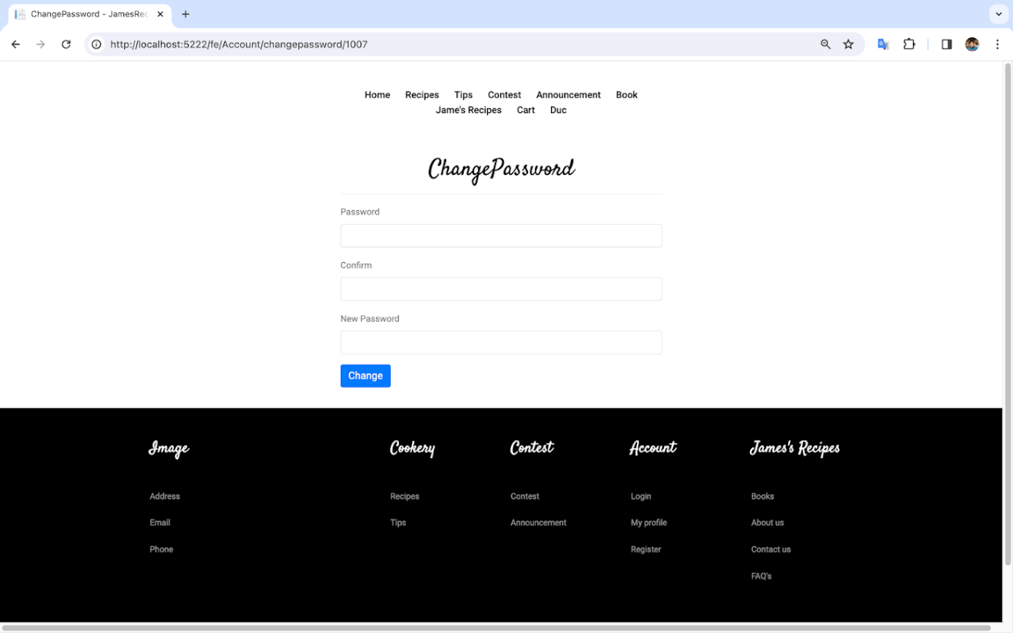

Description: User Change pass Page

From: fe/account

To: changepassword/userid

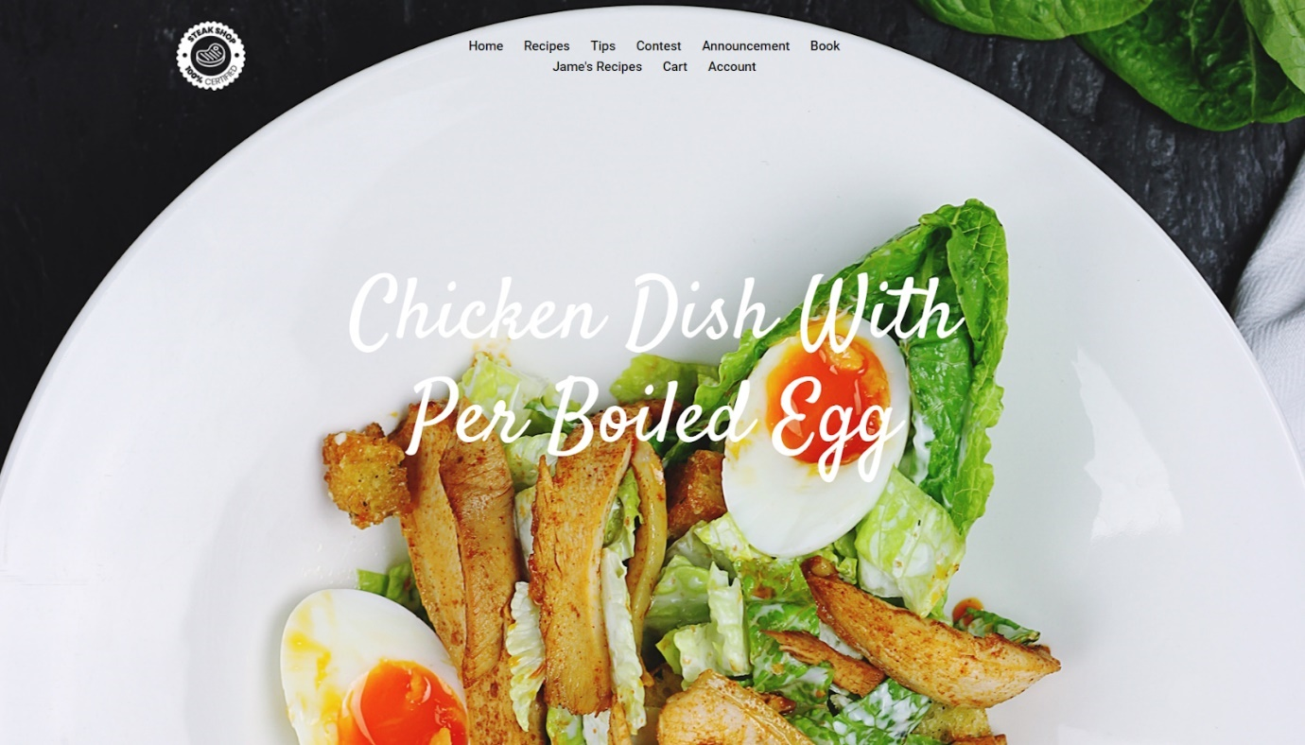

Description: Homepage

From: fe/account/login

To: Recipes/Tips/Contest/Contests Entries/Books/User Profile

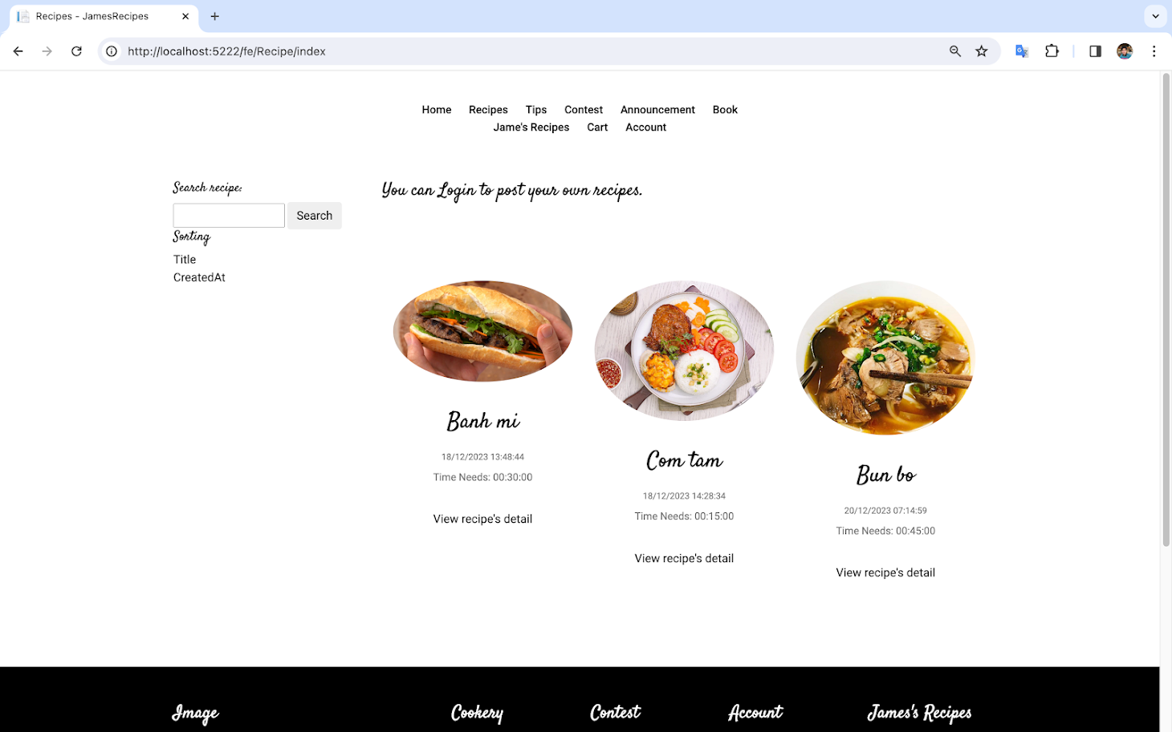

Description: Recipe Page

From: homepage

To: Recipes/Tips details

Description: Recipe Detail

From: fe/recipe/index

To: Recipe Details

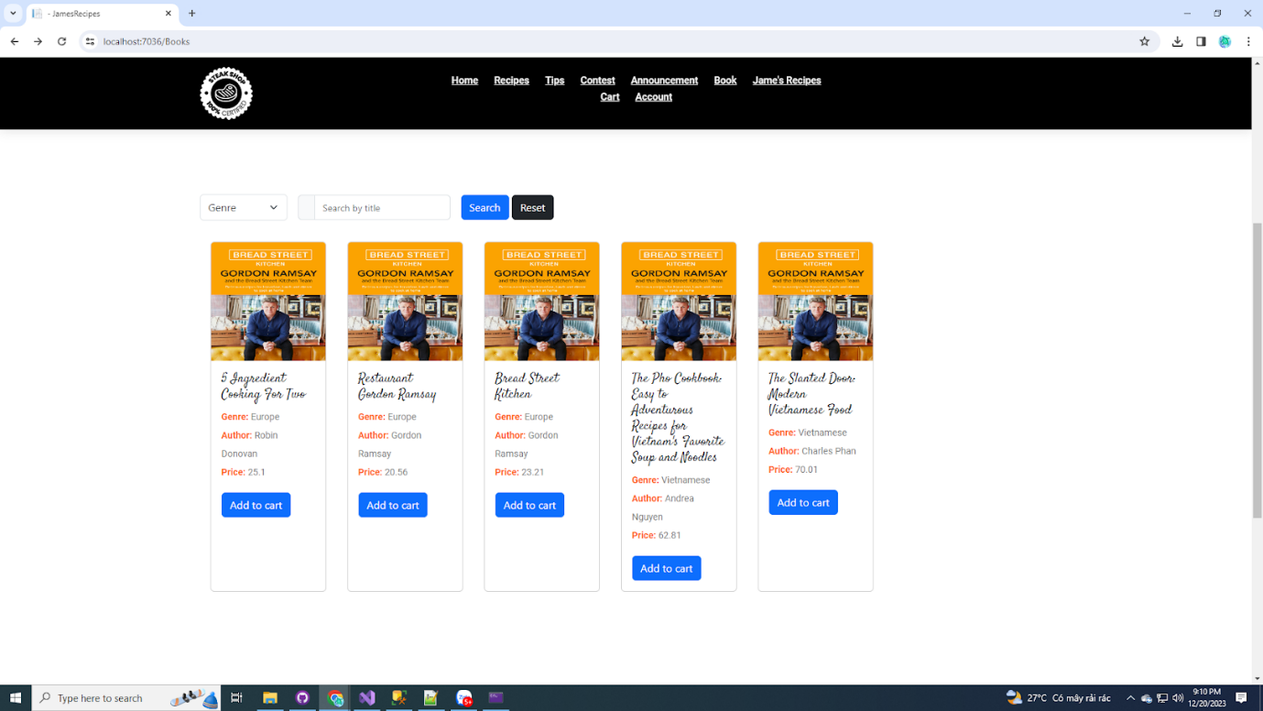

Description: Book Page

From: homepage

To: Book Details/carts/payments

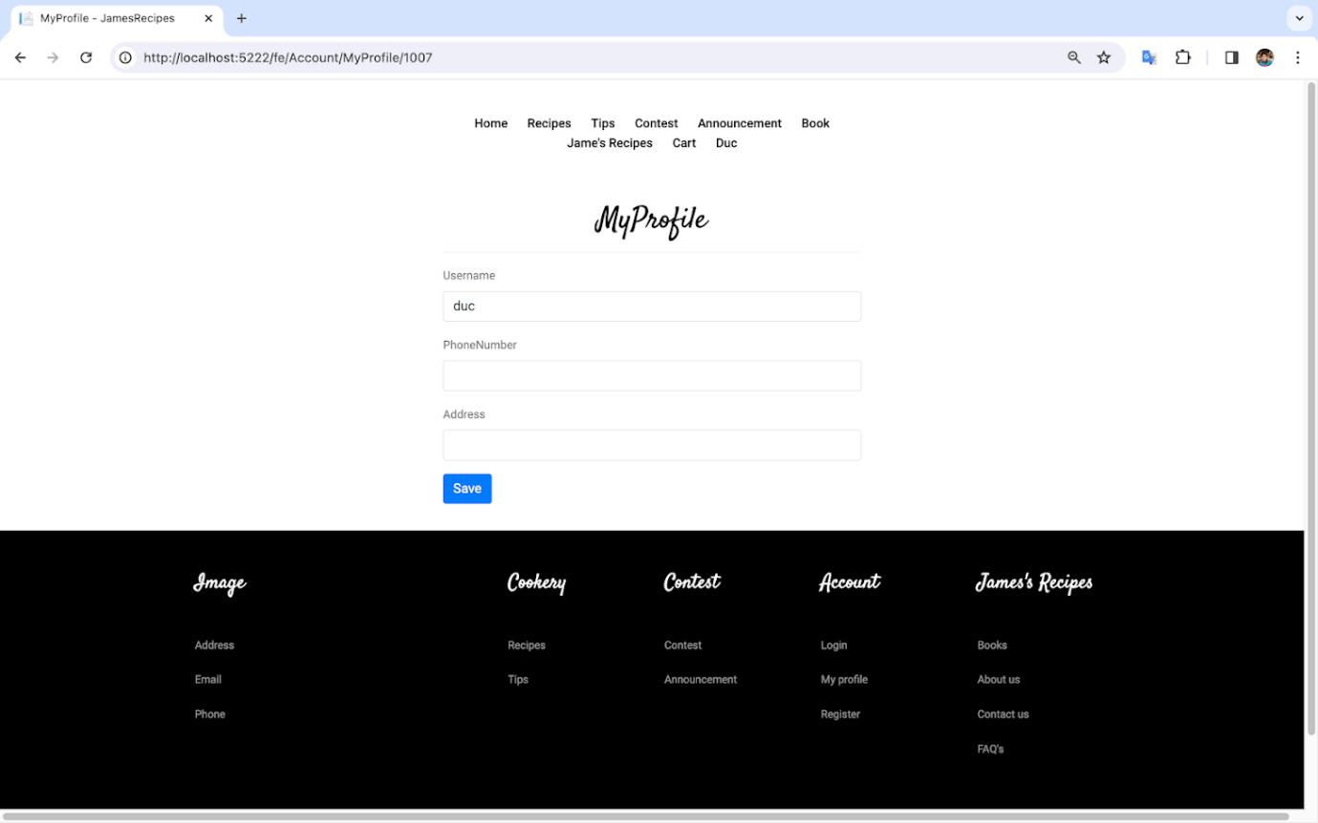

Description: User Profile Page

From: homepage

To: user de

**Announcement:**

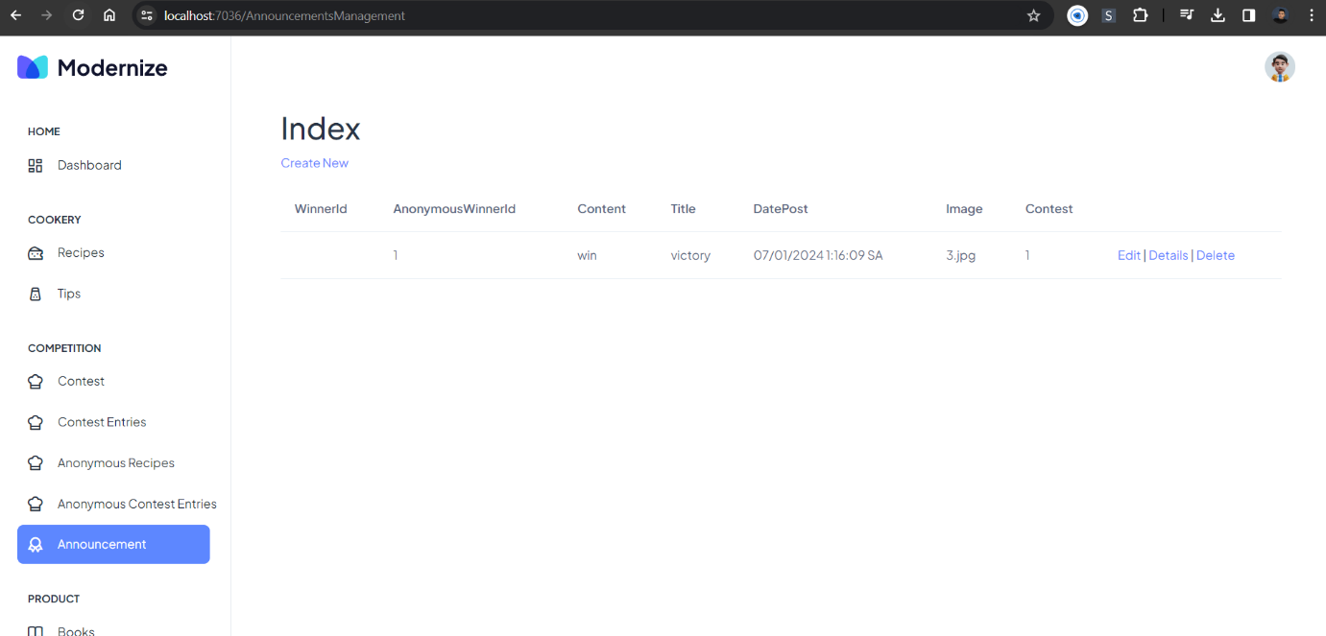

Description: Announcement Page

From: Admin Dashboard

To: Edit/create/delete announcements

**Paypal Function**

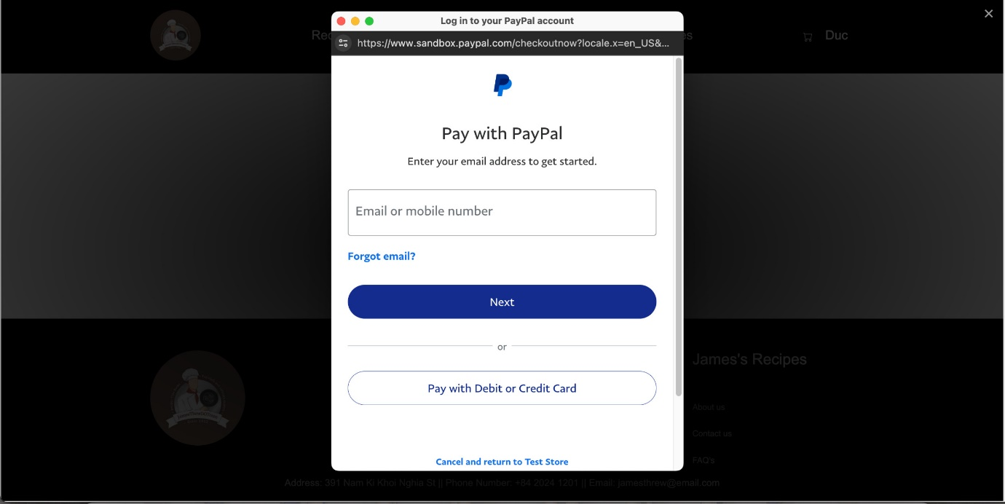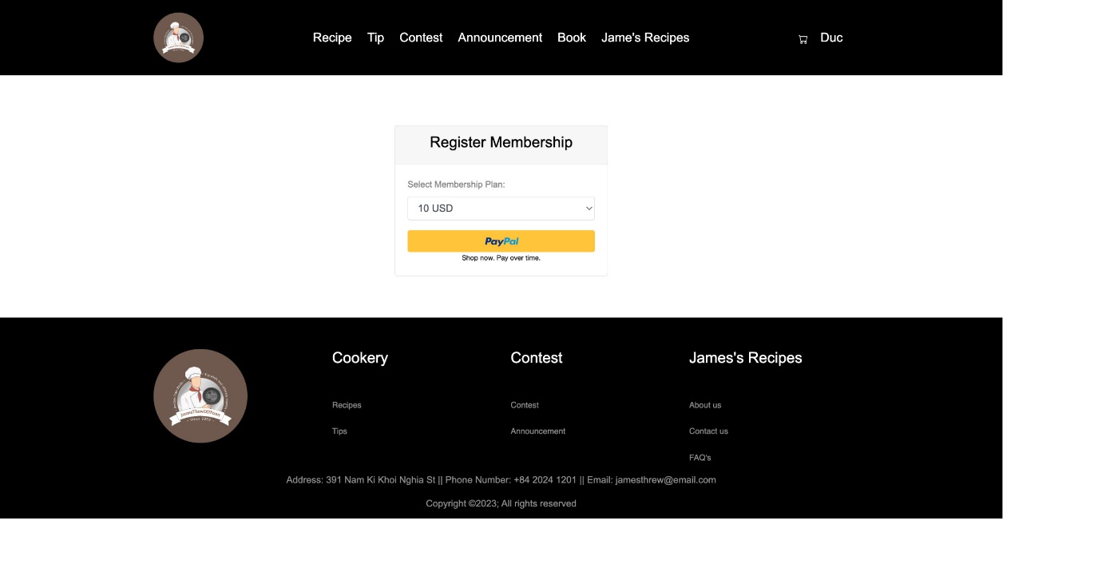

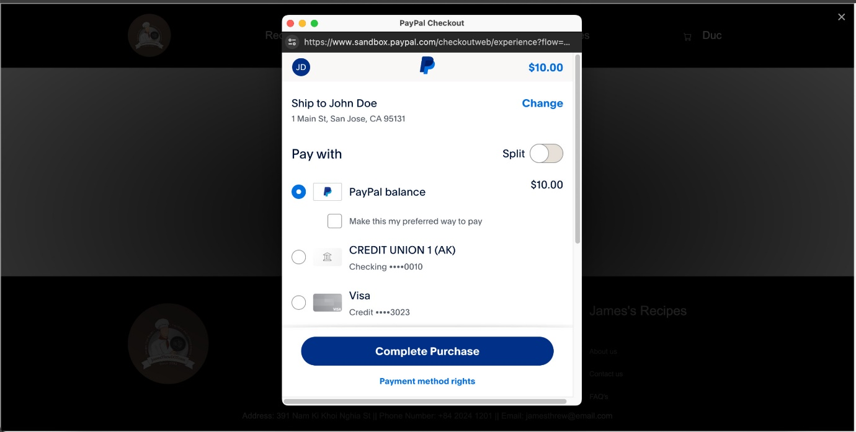

Description: Paypal Function

From: Register VIP Page

To: Completed Payment